2016

Jimmi Andersen, Marek Mikitovic and David Papp

Semester Project fourth Semester

16-12-2016

Process Report For Game-Console

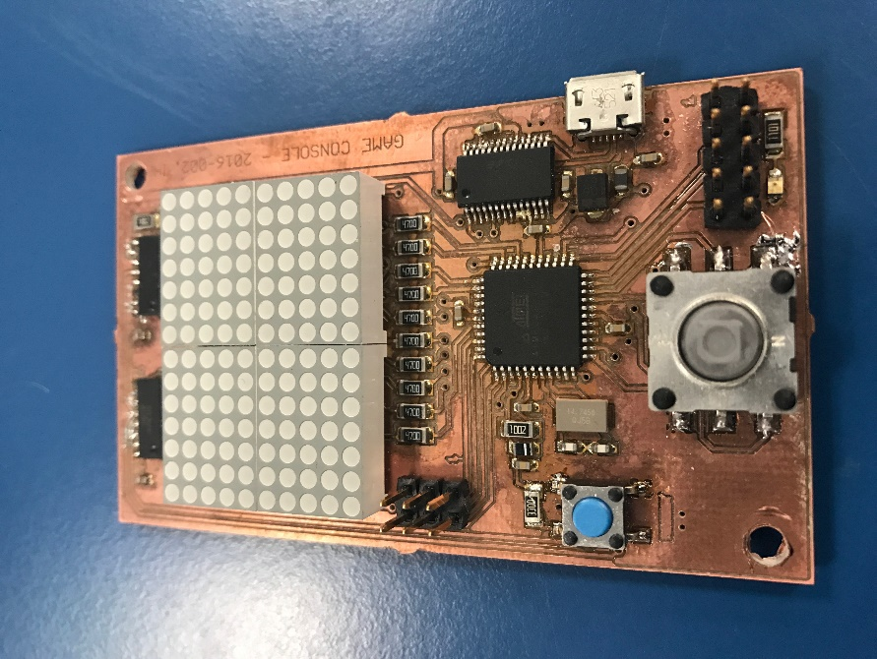

Table of Content.

Beggining of the project 2

Work flow 2

Brief timeline 2

Learning experience 3

# Beginning of the project

Our project supervisor was Ib Havn, with whom we spent few introduction hours at the beginning of our project, so we could revise our knowledge from RIE (​​​​​​​​Real-time-Programming Interfacing & Electronics) class. He advised us to focus on recapitulating knowledge we know about data layer and mainly about the protocols. What kind of design issues we can face or how to stuff bytes in to the frames (framing methods) What error control and flow control are. Exercises we have done were supposed to give us better understanding how before mentioned methods could be implemented in real life, thus it helps us creating our own protocol based on serial port communication.

# Work flow

We started as two students group, while we were developing our own solutions for given exercises such as different calculations for error corrections. There were some functional requirements that have to be met. Small brainstorm session revealed that the good direction would be to design ping pong based game on the display of this size and we started adding another non-functional requirement to the project.

Plan was simple divide project into smaller parts make them work and put it together. Then move one to another part. Our approach was simultaneously working on diagrams and code implementation of it, which seemed like not one of the best. Next time we would like to change that, by creating more detailed diagrams of different tasks and system, would help us more during the implementation. Later by irrefutable occasions was our group extended by one student. Which doesn’t change much but we had one extra worker to keep better focus on the project. We encountered lack of theory in some fields as creating task diagrams and unit testing.

This has been solved by discussing it with our supervisor and then we were pointed to a book where we found some inspiration and clue how should such a diagram look like. In the final implementation of the game, we found out that there were some bugs. Those were solved by testing and reviewing the implementation.

# Brief timeline

* Implementering First error checkin codes
* Design and implementation of byte stuffing and framing
* Design of first version protocol
* Design of game logic and diagrams
* Implementation of display function
* Implementation of player 1 movement
* Implementation of ball task, bouncing
* Design of early version of state machine and system diagram
* Testing single player stage of game
* Implemetation and testing of protocol and queue for received data
* First version of Java PC protocol communication
* Change of the game logic mapping of displaying position of players
* Added implementation of player 2 movement
* Testing the end of the round logic ball can bounce off the playground
* Update on state machine diagram
* Reimplementation to C# PC protocol communication
* Idle and game state working properly
* Implementation of displaying score state
* Further testing and debugging

# Improvements

Next time we could spend more time on proper diagrams especialy state machine from the beginning of the project. It’s more efficient to start” coding” design which is well described than, running into the problems in production.

Our protocol is very simple since we are sending only one byte of payload and as a response ACK or NACK. We could implement CRC or other error checking methods, but we got only two types of messages for moving up or moving down even if the message would be corrupted we still got enough time to resend another one. So the gameplay still wouldn’t be affected.

# Learning experience

During this project, we gained knowledge about protocols and different approaches of handling the data frames over physical layer. We were introduced into different techniques of error checking codes as parity bits, checksums, and CRC (cyclic redundancy codes) and even error repairing, Hamming codes. We improved our skills in using Free RTOS framework. How to use semaphores/mutexes or queues. Least but not last, we improved our software developing skills in embedded field since this was the larger and more complex project than previous projects.

# Self-reflection Jimmi

This project has been really excited to work on especially because I like to work with programming this kind of hardware however I must admit I am not the best programmer but have learned a lot working on this project but could still use more experience on the codding part. Ding this project I have handle most of the project documentation and this is something I have always handed to other group members therefore I am satisfied that I got to do this part to get better at documentations.

# Self-reflection Marek

# Self-reflection David